Microsoft Word - PR2-2024(02b1) (ASSIGNMENT-2) June 18, 2024

|  |  |
| --- | --- |
| ASSIGNMENT 1 | |
| TOPICS | TEXT FORMATTING & TABLE |
| BATCH | PR2-2024-02B1 |
| DATE ISSUED | 3/18/2024 |
| DATE EXPIRED | 3/21/2024 |
| ASSIGNMENT TYPE | MS OFFICE 2019 |
| SUBMIT FORMAT | MS OFFICE (2007 TO 2019) |

QUESTION: THIS IS AN APPLICATION SAMPLE; YOU NEED TO MAKE IT CONISE USING ANY AI TOOL AND THEN DO THE BASIC FORMATTING REQUIRED FOR THE APPLICATION FORMAT. OR TRY TO WRITE IT WITH YOUR BASIC KNOWLEDGE MENTIONED AS “YOUR NAME”, THIS WILL ENHANCE YOUR TYPING SKILL

**The Application for the**

**Mental Wellness**

**Companion" or "Mindful**

**Well:**

[Your Name]

[Your Address]

[City, State, ZIP]

[Email Address]

[Phone Number]

[Date]

[Recipient's Name]

[Recipient's Position]

[Organization Name]

[Organization Address]

[City, State, ZIP]

Dear [Recipient's Name],

**Subject**: Application for Development of a Mental Health and Well-being Application

I am writing to express my keen interest in developing a comprehensive mental health and well-being application in collaboration with [Organization Name]. As an advocate for mental health awareness and a skilled application developer, I am excited about the opportunity to contribute to a project that has the potential to make a positive impact on people's lives.

I have witnessed the growing need for accessible mental health resources and support, especially in today's fast paced and stressful world. Recognizing this, I propose the development of an application that focuses on promoting mental well-being, providing valuable tools, and connecting individuals with the necessary resources.

The key features of the proposed mental health and well-being application would include:

Mood Tracker: A user-friendly interface to log and track daily moods, enabling individuals to identify patterns, triggers, and overall mental well-being over time.

Guided Meditations: A library of guided meditation sessions designed to reduce stress, promote relaxation, and improve overall mental well-being. Users can choose from various meditation styles and durations based on their preferences

Stress Management Techniques: Practical tips and techniques to manage stress effectively, including breathing

exercises, mindfulness practices, and stress reduction strategies that can be easily integrated into daily routines.

Self-help Resources: A curated collection of articles, videos, and informative content covering various mental

health topics such as anxiety, depression, self-care, resilience, and positive psychology. This section will

empower users with knowledge and tools to support their mental well-being journey.

Support Networks: Integration with local mental health support groups, helplines, and professional resources to

connect individuals with appropriate assistance when needed. This feature will ensure that users can access

timely support and reach out to trained professionals in times of crisis.

I am confident that this application will help raise awareness about mental health, provide individuals with

essential resources and foster a supportive community. It aligns perfectly with the mission and vision of

[Organization Name] in promoting mental well-being and reducing the stigma surrounding mental health issues.

I would be honored to collaborate with [Organization Name] in developing this application. I bring my expertise

in application development, a deep understanding of mental health concerns, and a passion for making a

meaningful difference in people's lives. Together, we can create a powerful tool that empowers individuals to

prioritize their mental well-being.

I would appreciate the opportunity to discuss this proposal further and explore how we can proceed with this

project. Please find attached my detailed project proposal, which includes a timeline, budget estimates, and

additional information about my experience and qualifications.

Thank you for considering my application. I look forward to the possibility of working together and making a

positive impact on mental health and well-being.

Sincerely,

[Your Name]

**My Task**

Video provides a powerful way to help you prove your point. When you click Online Video, you can paste in the embed code for the video you want to add. You can also type a keyword to search online for the video that best fits your Document.

To make your document look professionally produced, Word provides header, footer, cover page, and text box designs that complement each other. For example, you can add a matching cover page, header, and sidebar. Click Insert and then choose the elements you want from the different galleries.

Themes and styles also help keep your document coordinated. When you click Design and choose a new Theme, the pictures, charts, and SmartArt graphics change to match your new theme. When you apply styles, your headings change to match the new theme.

Save time in Word with new buttons that show up where you need them. To change the way a picture fit in your document, click it and a button for layout options appears next to it. When you work on a table, click where you want to add a row or a column, and then click the plus sign.

Reading is easier, too, in the new Reading view. You can collapse parts of the document and focus on the text you want. If you need to stop reading before you reach the end, Word remembers where you left off - even on another device.

Video provides a powerful way to help you prove your point. When you click Online Video, you can paste in the embed code for the video you want to add. You can also type a keyword to search online for the video that best fits your Document.

To make your document look professionally produced, Word provides header, footer, cover page, and text box designs that complement each other. For example, you can add a matching cover page, header, and sidebar. Click Insert and then choose the elements you want from the different galleries.

Themes and styles also help keep your document coordinated. When you click Design and choose a new Theme, the pictures, charts, and SmartArt graphics change to match your new theme. When you apply styles, your headings change to match the new theme.

Save time in Word with new buttons that show up where you need them. To change the way a picture fit in your document, click it and a button for layout options appears next to it. When you work on a table, click where you want to add a row or a column, and then click the plus sign.

Reading is easier, too, in the new Reading view. You can collapse parts of the document and focus on the text you want. If you need to stop reading before you reach the end, Word remembers where you left off - even on another device.

Video provides a powerful way to help you prove your point. When you click Online Video, you can paste in the embed code for the video you want to add. You can also type a keyword to search online for the video that best fits your Document.

To make your document look professionally produced, Word provides header, footer, cover page, and text box designs that complement each other. For example, you can add a matching cover page, header, and sidebar

***V*ideo** provides a powerful way to help you prove your point. When you click Online Video, you can paste in the embed code for the video you want to add. You can also type a keyword to search online for the video that best fits your document.

To make your document look professionally produced, Word provides header, footer, cover page, and text box designs that complement each other. For example, you can add a matching cover page, header, and sidebar. Click Insert and then choose the elements you want from the different galleries.

Themes and styles also help keep your document coordinated. When you click Design and choose a new Theme, the pictures, charts, and SmartArt graphics change to match your new theme. When you apply styles, your headings change to match the new theme.

Save time in Word with new buttons that show up where you need them. To change the way a picture fits in your document, click it and a button for layout options appear next to it. When you work on a table, click where you want to add a row or a column, and then click the plus sign.

Reading is easier, too, in the new Reading view. You can collapse parts of the document and focus on the text you want. If you need to stop reading before you reach the end, Word remembers where you left off - even on another device.

Microsoft Word - PR2-2023(06E-06C) (ASSIGNMENT-2) June 18, 2023

Video provides a powerful way to help you prove your point. When you click Online Video, you can paste in the embed code for the video you want to add. You can also type a keyword to search online for the video that best fits your Document.

To make your document look professionally produced, Word provides header, footer, cover page, and text box designs that complement each other. For example, you can add a matching cover page, header, and sidebar. Click Insert and then choose the elements you want from the different galleries.

Themes and styles also help keep your document coordinated. When you click Design and choose a new Theme, the pictures, charts, and SmartArt graphics change to match your new theme. When you apply styles, your headings change to match the new theme.

Save time in Word with new buttons that show up where you need them. To change the way a picture fits in your document, click it and a button for layout options appear next to it. When you work on a table, click where you want to add a row or a column, and then click the plus sign.

Reading is easier, too, in the new Reading view. You can collapse parts of the document and focus on the text you want. If you need to stop reading before you reach the end, Word remembers where you left off - even on another device.

**My Story in One Paragraph**

|  |
| --- |
| **Video provides a powerful way to help you prove your point. When you click Online Video, you can paste in**  **the embedded code for the video you wants to add.** |
| **You can also type a keyword to search online for the video that best fits your document. To make your**  **document look professionally produced, Word provides header, footer, cover page, and text box designs**  **that complement each other.** |

|  |
| --- |
| **~~For example, you can add a matching cover page, header, and sidebar. Click Insert and then~~**  **~~choose the elements you want from the different galleries.~~**  **~~Themes and styles also help keep your document coordinated. When you click Design and~~**  **~~choose a new Theme, the pictures, charts, and SmartArt graphics change to match your new~~**  **~~Theme.~~**  **~~When you apply styles, your headings change to match the new theme. Save time in Word with~~** |
| **To change the way a picture fits in your document, click it and a button for layout options appears next**  **to it. When you work on a table, click where you want to add a row or a column, and then click the plus**  **sign.**  **Reading is easier, too, in the new Reading view. You can collapse parts of the document and focus on the** |

***~~If you need to stop reading before you reach the end, Word remembers where you left off - even on another device. Video provides a powerful way to help you prove your point.~~***

***~~When you cliffy Online Video, you can paste in the embed code for the video you want to add. You can also type a foreword to search online for the video that best fits your document.~~***

***~~To Maffie your document lo-fi professionally produced, Word provides header,footer, cover page, and text box designs that complement each other. For example, you can add a matching cover page, header, and sidebar.~~***

|  |  |  |  |  |
| --- | --- | --- | --- | --- |
| **MY DATA SYSTEM** | | | | |
|  | NAME | AGE | MON | SALARY |
| Ali | 23 | Sat | 12,000 |
| Mai | 34 | Mon | 24,000 |
| Shai | 23 | Tue | 72,000 |
| Mosa | 56 | Mon | 216,000 |
| Anil | 43 | Tue | 648,000 |
| Poha | 75 | Thurs | 1,944,000 |
| Sahil | 34 | Wed | 5,832,000 |
| Kahli | 21 | Mon | 17,496,000 |
| My Total | | | | (Calculate sum) |

|  |  |  |  |  |  |
| --- | --- | --- | --- | --- | --- |
| SALARY SHEET | | | | | |
| MILLS AND SUGAR & CO. | | THE YEAR  1997 | | | |
| QRT1 | QRT2 | QRT3 | QRT4 |
|  | NAME | 1200 | 1800 | 1200 | 1100 |
| JACK | 1300 | 3400 | 4500 | 1971.43 |
| MALL | 1200 | 2076428.57 | 1710000 | 366428.57 |
| SIN | 4500 | 1200 | 514710000 | 11029 |
| PAL | 1710000 | 45000 | 15492771 | 331987 |
| LEO | 514710000 | 1710000 | 46633240 | 99928372 |
| WALL | 1300 | 514710000 | 140366054 | 300784402 |
| CALCULATIONS | | SUM | MMIN | MAX | AVERAGE |

|  |  |  |  |  |  |  |  |
| --- | --- | --- | --- | --- | --- | --- | --- |
|  | | 1999 | | 2000 | | 2001 | |
| INCOME | COST | INCOME | COST | INCOME | COST |
| SPRING | LOCAL |  |  |  |  |  |  |
| NATIONAL |  |  |  |  |  |  |
| SUMMER | LOCAL |  |  |  |  |  |  |
| NATIONAL |  |  |  |  |  |  |
| FALL | LOCAL |  |  |  |  |  |  |
| NATIONAL |  |  |  |  |  |  |
| WINTER | LOCAL |  |  |  |  |  |  |
| NATIONAL |  |  |  |  |  |  |

Work Out with David

A series of introductory exercise classes with

Personal Trainer David Fairmont

|  |  |  |
| --- | --- | --- |
| Work Out with  David | **Schedule** | |
| January 8 | Step Aerobics |
| Pilates |
| January 15 | Spinning |
| Yoga |
| January 22 | Kickboxing |
| Free Weights |
| Space is limited. Please sign up as soon as possible | |

Work Out with David is a series of three classes designed to introduce members to some of the exercise opportunities here at Michigan Avenue Athletic Club.

Each hour-long session focuses on two complementary types of exercise. The first 15 minutes will be spent learning about the exercises, including the equipment that may be involved. The rest of the class includes a warm up, active participation and a cool down.

David Fairmont is our newest personal trainer. He holds a master’s degree in health management from the University of Vermont in Burlington, Vermont, and he is certified in cardiovascular exercise and strength training.

Work Out with David is geared toward those with limited exercise class experience, but all members are welcome to join.

**HOME ABOUT-US GALLARY CONTACT-US**

|  |  |  |
| --- | --- | --- |
| |  | | --- | |  |   THIS IS MY JOURNEY WITH FEW CASES, WITH  FEW MEMORIES AND WHAT I HAVE IS MY  GOOD LIFE AND GRATEFUL FRIENDS |  |
| **Video provides a powerful way to help you prove your point. When you click Online Video, you can paste in the embed code**  **for the video you want to add. You can also type a keyword to search online for the video that best fits your document.**  **To make your document look professionally produced, Word provides header, footer, cover page, and text box designs that**  **complement each other. For example, you can add a matching cover page header, and sidebar. Click Insert and then choose**  **the elements you want from the different galleries.** | |
| **SHOW YOUR BEHAVIOUR AND SYSTEM LOGISTICS** | |

Name: Abdul Wahab Amir Aptech Metro Star Gate

# MONTHLY CLASS SCHEDULED ACTIVE FROM MONDAY

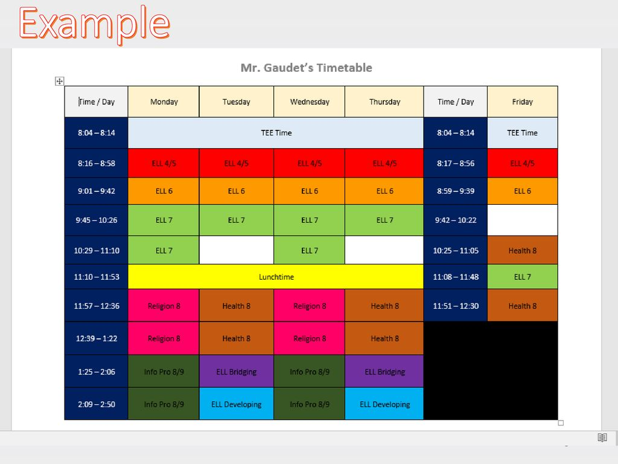

# YEARLY TIME TABLE

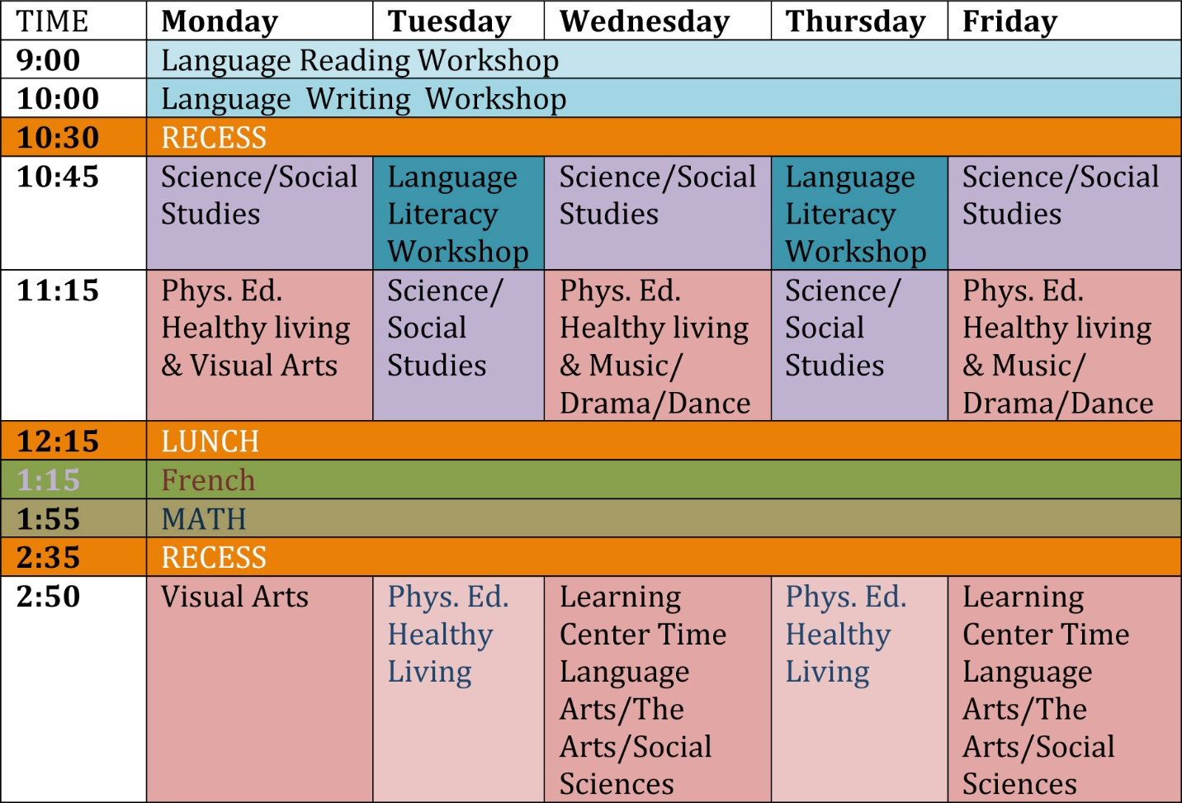

# Me Favorite Tabular Structure

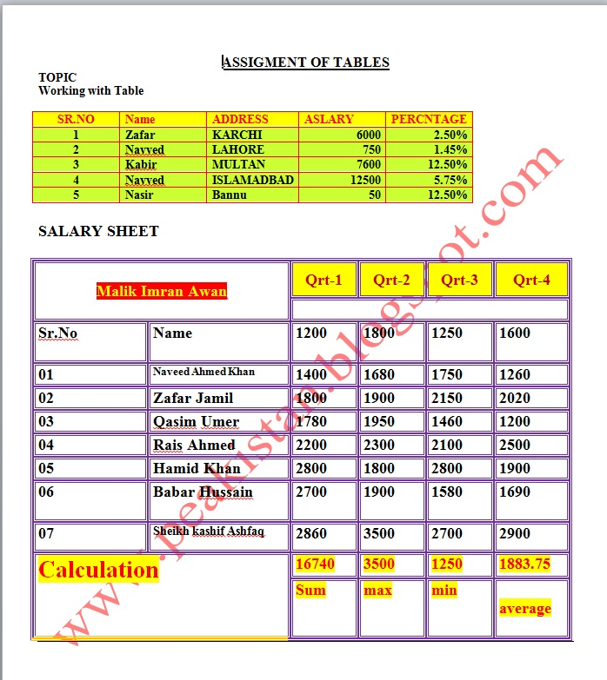

# CONDITION WISE STRUCTURE

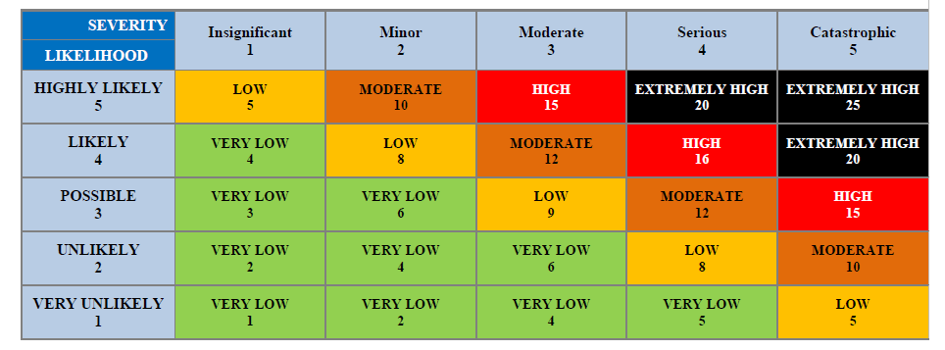

# RISK ASSESMENT WORKSHEET

